 Follow the steps below to be added as a Business Role resource for "***Non SAP Access to Insider Information***" on the [**UDS**](https://uds.accenture.com/) Page.

1. Login into [**https://uds.accenture.com**](https://uds.accenture.com)
2. Click on *"New"* icon, at the left side:  
   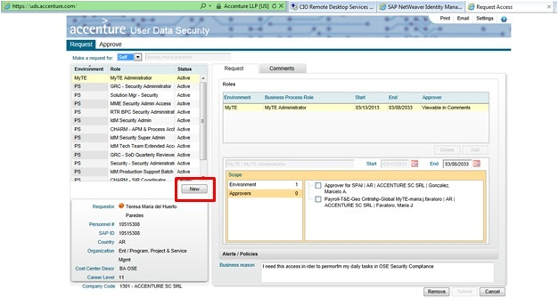

3.       Type “Non SAP Access to Insider Information” (It’s important to type the role. Do not copy it):

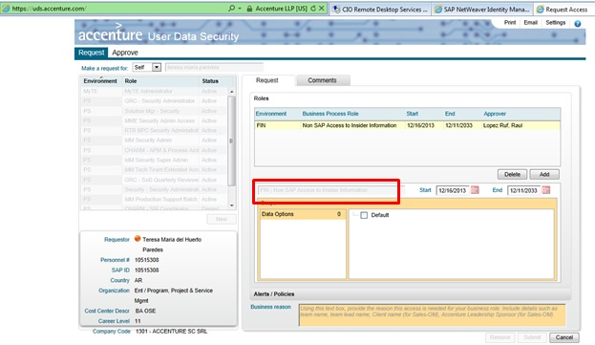

4.  If you work in a project and you know its End Date, you can select a Start and End Date. This access will expire 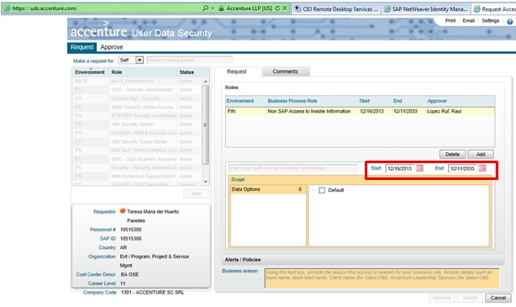on selected date with no further action from your side. **NOTE:** Take into consideration that if you have a SAP Role that makes you Insider, you will remain in the list.

5.        Click on “Default” and provide a valid reason on “Business Reason”:

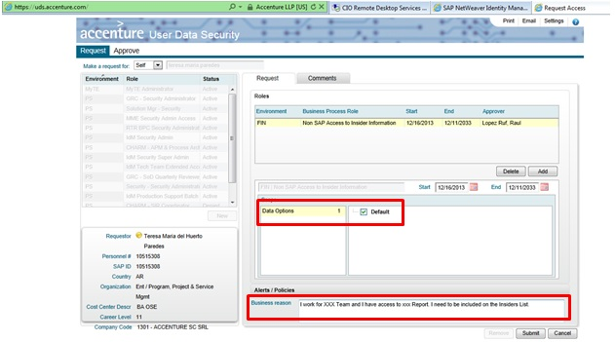

Example of a valid Business Reason:

“I work on the CTC Analytics Program -------------------- team, my manger is ----------------. I need to be included in the Insider Trading List as I have access to Material, Non-Public Information.

6.       Click OK to confirm your submission. You will receive an Insider Alert as below:

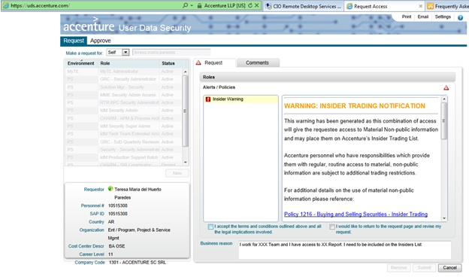

Click on “I accept the terms and conditions outlined above and all the legal applications involved”

7.       Click “Ok”:

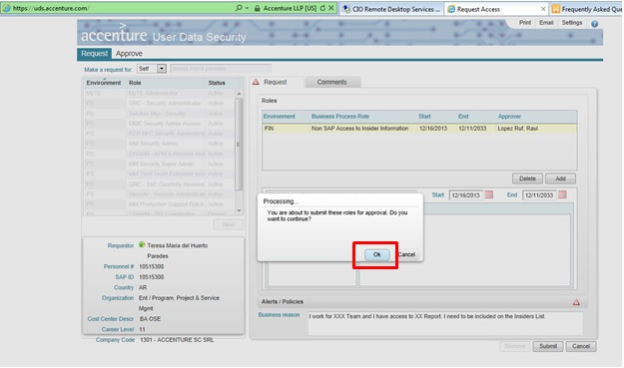

Once request is approved (Status "Active" in UDS Page), you will be effectively added to the Insider Trading List the next time List is generated. Usually 15 days before window opens or closes.

IMPORTANT: Please notice that users that need to be added to the list must personally request this Non SAP Access Role on UDS as this cannot be proxied.

If you have any questions, please contact [OSE Security Compliance Team](mailto:OSE.Security.Compliance@accenture.com?subject=Question%20on%20Insider%20List).